Toothpaste Dispenser
Group 10
Cornerstone of Engineering-GE1502
Simon Hume, Bora Bromberg, Chris Sparrow
April 15, 2026
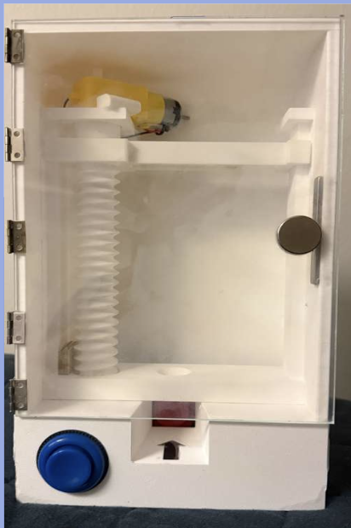

Table of Contents
Abstract pg.3
Problem and Definition pg.3
Generate and Decide pg.4
Implement and Interate pg.6
Evaluate - Final Design pg.8
Reflection pg.9
References pg.11
Appendix pg.12

Abstract
Throughout this project, we worked to help build a dental hygiene device that would be beneficial to the dentistry field. We focused on the use of toothpaste and how people with mobility issues may not be able to squeeze a toothpaste tube. To attack this problem, we built a toothpaste dispenser out of 3D-printed parts and a micro-py. We used SolidWorks in order to design the 3D printed parts and Thonny for the micro-py. Using the components, we met the needs of our problem and used the knowledge we have learned in the past two semesters to do so. Overall, we were able to come up with a solution to the problem with the resources in a creative and innovative way.

Problem and Definition
The problem we focused on is the struggle to apply toothpaste for users with dexterity issues, including arthritis, Parkinson's, and anything else that might hinder someone's ability to move their hands to the necessary amount to squeeze a toothpaste tube, which could be solved with a self-dispensing toothpaste device. We also recognized that dentists say to use a pea-sized amount of toothpaste when you are an adult and a rice-sized amount for children. More than 38% of children use too much toothpaste. Dentists also recommend specific amounts of toothpaste for specific ages.
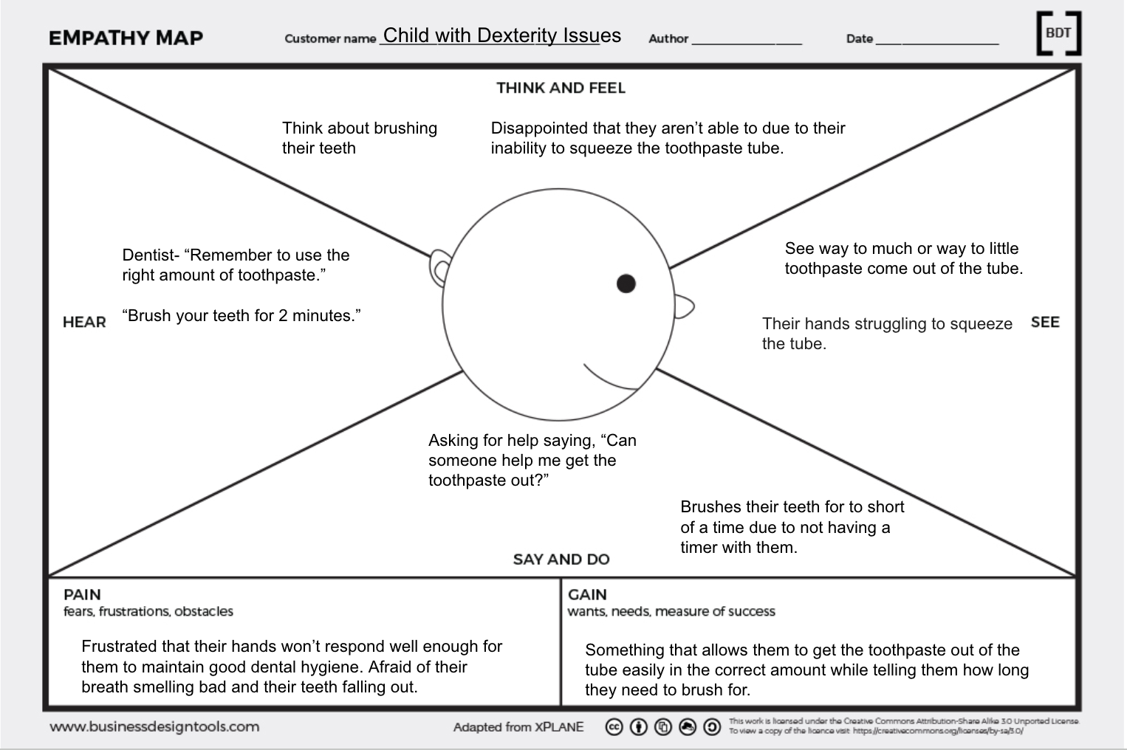
(Empathy Map)
This empathy map reflects the ideal user for our product and who we are making it for. The overall objective of our project was to make a product that could dispense toothpaste effectively for people of all ages and people with motor issues.

Generate and Decide
When coming up with ideas for our project, we used the Scamper method.
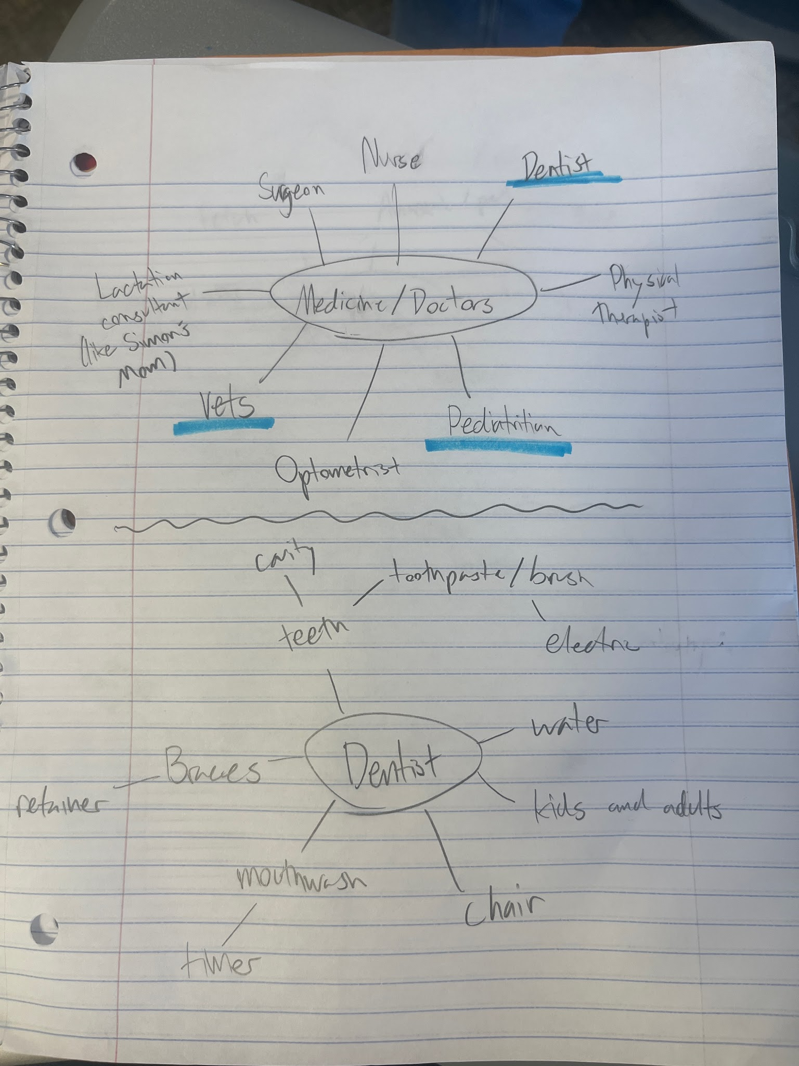
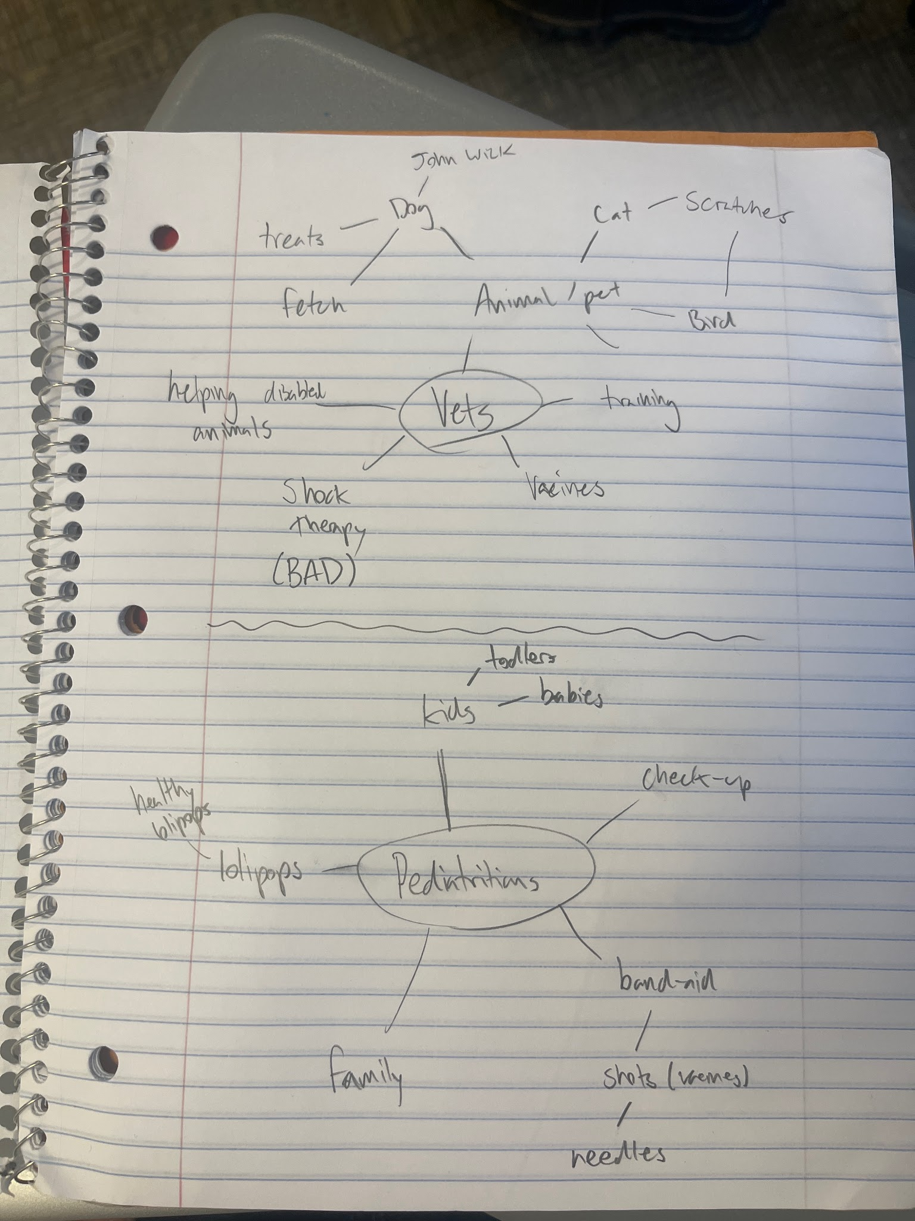

(Scamper Method)

We focused on health care professionals and what issues they may have, until we finally decided on dentists because we felt like they may have some unique problems. While deciding on a problem to make a product for, we came up with three main ideas.
Dog Treat Launcher - Veterinarian
  - A dog toy catapult to encourage exercise and weight loss for dogs
  - Would function without human interaction
  - It could easily be created using Pico parts, mainly the motor for the launching and a motion sensor when the dog retrieves the ball.
  - There could also be calculations in the Python program that calculate how far your dog has run and how many calories they've burned.
  - Users: Dogs, their owners, and their veterinarians.
Auto Tooth Paste Dispenser - Dentists
  - Access-friendly automatic toothpaste dispenser.
  - Dispenses the recommended amount of toothpaste each time
  - It could be created using a servo that “rolls out” the correct amount of toothpaste each time.
  - Python code could also roll the appropriate amount based on the age of the user.
  - Users: Kids, adults, dentists, people with dexterity issues.
Resolving shot dispenser (for kids) - Pediatrician
  - Multiple medicine cartridges with one needle, concealing the needle
  - Kid-friendly design that creates a less “scary” design.
  - Could be made using servos to rotate the valve and SolidWorks to create the housing unit.
  - Users: Kids and their pediatricians.

After looking over these ideas, we decided on the toothpaste dispenser. Through our research for this, we found that mechanical toothpaste dispensers do exist; however, without the electrical aspects that we plan on including, namely sensors, servo motors, and programming that dictates the amount of toothpaste dispensed. This allowed us to follow through on our design idea due to the lack of solving the problem we are focusing on. For our final decision on a design, we sketched to get a rough idea of how it would work.
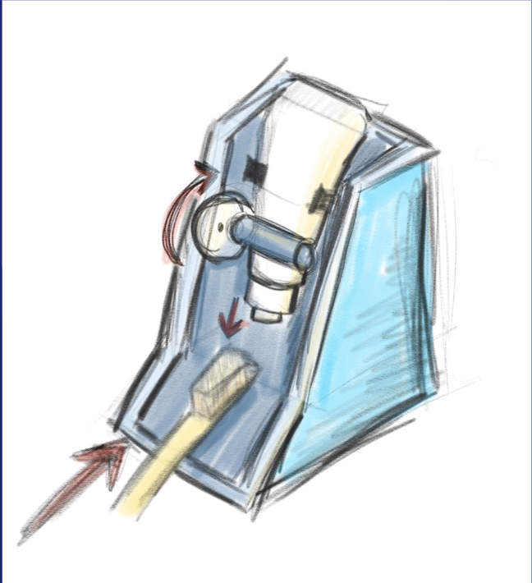
(Original Sketch)
We imagined a motor moving a 3D printed piece to squeeze out the toothpaste. The toothpaste tube is connected to the back of a 3D printed base to allow for the piece that's moving to inflict pressure on the tube.
Implement and Interate
Through our process of designing and making the product, we went through 3 main prototypes. We started with the cardboard prototype, which involved us taking the sketch and trying to make a base idea for what our product should become and what needs to change.
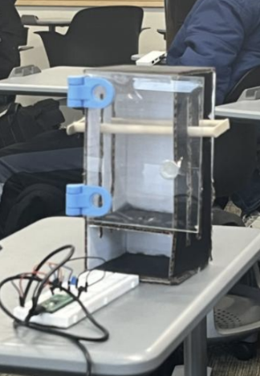
(Prototype 1)
Through this process, we discovered that the housing mechanism, being a whole box, would be better for housing electronics and making the squeezing mechanism actually move up and down. Through that, we realized that the user would need to see the toothpaste to know when the toothpaste tube is empty, and a mechanism to reset it once it hits the bottom, so we added a clear door. The pico aspect of this cardboard prototype involves a button that activates a light to show that it works, which would go in the back of the box, and needs to have a more effective button. We also recognized we don’t have a direct place for the toothpaste.
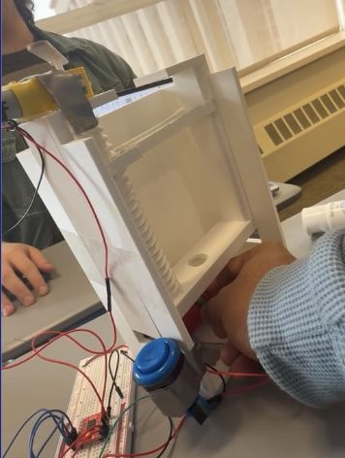
(Prototype 2)
This is the first 3D printed version of the design. Issues we noticed with this design are that we were still lacking space for the electronics and an exact spot for the toothpaste. We did add a second button that controls the settings for the amount of toothpaste. Both buttons are more sensory-friendly and clearer on when you make contact with the button. We added the cork screw that moves the squeezer up and down. The cork had issues with moving within the box because of the tightness of the plastic holding it, and the lack of the 360 servo motor connecting to it correctly. Overall, it has the correct ideas and acted as a partial proof-of-concept, but needs to have some changes made to it.

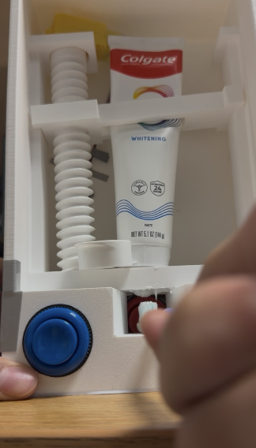
(Prototype 3)
The final prototype before the final design has space for the buttons, and they are put in their designated spots. The motor is connected to the cork screw and moves correctly to move the squeezing piece up and down. We have a clear, designated slit for insertion of the toothbrush. The coding is also all done to enable the movement needed and change the settings (Appendix). The squeezing piece doesn’t have enough slack to move properly, and we don’t have a place to put the breadboard that holds all the wires. It’s also missing the seethrough door to allow for key visuals.

Evaluate - Final Design
Our final design fixed all of the issues we found through prototyping. It also met the need for the problem of using too much toothpaste and toothpaste being hard to use for people with motor skill issues.
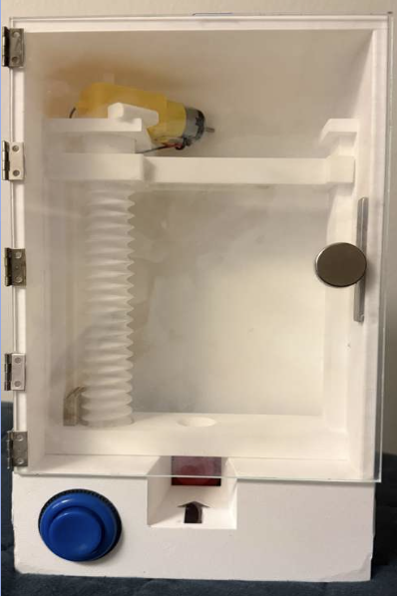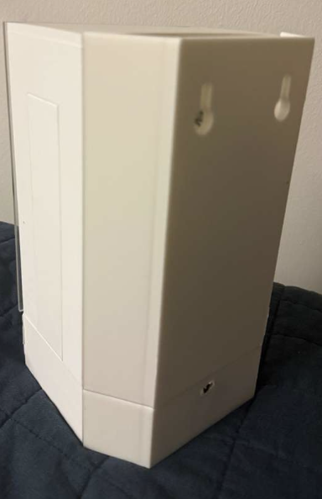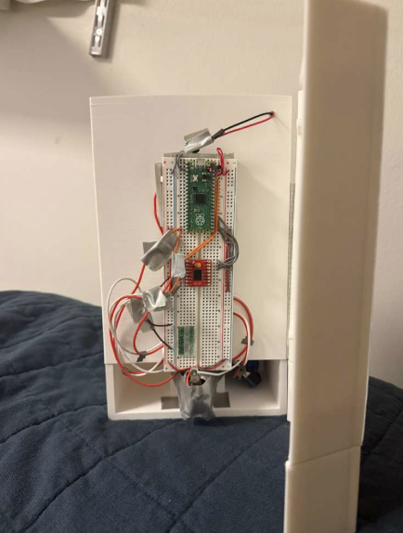
(Final Design)
In our final design, we added an arrow to show where the direction of the toothbrush should be inserted. We also added a housing unit for the electronics on the back of the box. We fixed the issue with the arm that moves up and down so it moves more fluidly. We added the see-through door to add to the sleeker design and allow for easy change of the toothpaste tube. We also added wall mounts on the back to show how it would function and where it would go if it were used in a bathroom. Overall, the design is pretty well made and meets the user's needs and solves the problem of people with dexterity issues using toothpaste.

Reflection
Our biggest issue throughout our project was integration. Integrating the Pico aspect with the SolidWorks aspect took multiple trials in order to make the integration correct. Our project was safe and capable of completing the task that we set out to do. The integration was truly the biggest issue, but we felt like that could have been because of the separation during breaks or other issues. As much as we did run into issues, we felt like we were on top of them and were easily able to adapt and compromise through disagreements. Through this, we were able to create a working product that solved the problem that we had at hand.

Refrences
[1] American Dental Association, “Home Oral Care Recommendations to Reduce the Risk of Caries and Gum Disease,” Jul. 22, 2024. [Online]. Available: https://www.ada.org/-/media/project/ada-organization/ada/ada-org/files/resources/library/oral-health-topics/ada_home_oral_care_flyer_2024july22.pdf Accessed: Jan. 26, 2026.

[2] American Dental Association, “Toothbrushes,” Oct. 7, 2022. [Online]. Available: https://www.ada.org/resources/ada-library/oral-health-topics/toothbrushes. Accessed: Jan. 26, 2026.

[3] American Academy of Pediatric Dentistry, “Best Practices: Fluoride Therapy,” The Reference Manual of Pediatric Dentistry, 2025. [Online]. Available:https://www.aapd.org/media/Policies_Guidelines/BP_FluorideTherapy.pdf. Accessed: Jan. 26, 2026.

[4] Centers for Disease Control and Prevention, “About Dental Fluorosis,” May 15, 2024. [Online]. Available: https://www.cdc.gov/oral-health/about/about-dental-fluorosis.html. Accessed: Jan. 26, 2026.

[5] G. Thornton-Evans et al., “Use of Toothpaste and Toothbrushing Patterns Among Children and Adolescents — United States, 2013–2016,” MMWR Morb. Mortal. Wkly. Rep., vol. 68, no. 4, pp. 87–90, Feb. 1, 2019. [Online]. Available: https://www.cdc.gov/mmwr/volumes/68/wr/mm6804a3.htm. Accessed: Jan. 26, 2026.

Appendix
Final CAD Assembly
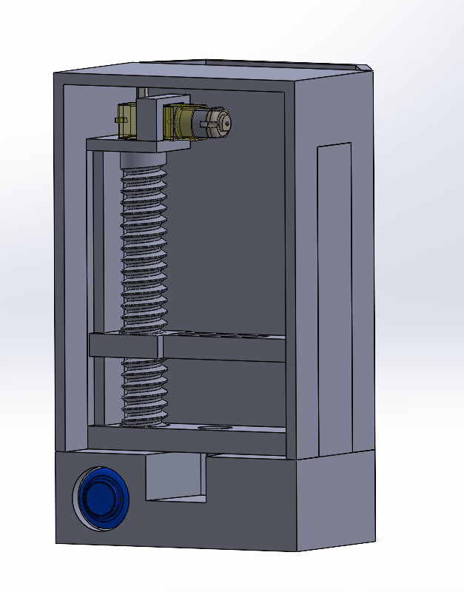
Final Code
from machine import Pin, PWM
import time

#pinouts
BUTTON1pin = 14 # settings button
BUTTON2pin = 15 # start button

STBYpin = 16
PWMApin = 17
AIN1pin = 18
AIN2pin = 19

#fixed variable setup
ChildDuration = .25 #seconds
AdultDuration = .5 #seconds

DebounceMs = 25 #for button to avoid multiple presses when pressed
DoubleClickMs = 600 #max time between two presses for a double click

PwmFreq = 1000 #signal switch off and on
MotorDuty = 65535 #max power

#button and motor driver setup
button1 = Pin(BUTTON1pin, Pin.IN, Pin.PULL_UP) #button1 changes from adult to child setting
button2 = Pin(BUTTON2pin, Pin.IN, Pin.PULL_UP) #button2 starts the motor

stby = Pin(STBYpin, Pin.OUT) #on off pin
ain1 = Pin(AIN1pin, Pin.OUT) #rotational direction
ain2 = Pin(AIN2pin, Pin.OUT) #rotational direction

pwma = PWM(Pin(PWMApin))
pwma.freq(PwmFreq)
pwma.duty_u16(0) #starts motor off

stby.value(1) #enables driver

#variables
TimeSetting = AdultDuration #starts at adult by default
MotorForward = True #starts motor in forward direction

#Setup buttons for main loop
b1StableState = button1.value() #value used after debounce
b1LastRaw = b1StableState #if signal change
b1LastChange = time.ticks_ms() #how long since last change - used for debounce

b2StableState = button2.value()
b2LastRaw = b2StableState
b2LastChange = time.ticks_ms()

b1WaitingSecondClick = False #tracks if first click happened and waiting for second
b1FirstClickTime = 0 #stores time of first click

#motor setup
def motor_stop():
pwma.duty_u16(0) #sets power to 0
ain1.value(0) #no direction
ain2.value(0) #no direction

def motor_forward(durationSeconds):
if MotorForward:
print("Motor forward for", durationSeconds, "second(s)")
ain1.value(1) #in this direction
ain2.value(0) #and not in this direction
else:
print("Motor reverse for", durationSeconds, "second(s)")
ain1.value(0) #in this direction
ain2.value(1) #and not in this direction

pwma.duty_u16(MotorDuty) #max power defined above
time.sleep(durationSeconds)
motor_stop()
print("Motor stopped")

#button
def toggle_setting():
global TimeSetting

if TimeSetting == AdultDuration:
TimeSetting = ChildDuration
print("Mode changed to: CHILD")
print("TimeSetting =", TimeSetting, "second(s)")
else:
TimeSetting = AdultDuration
print("Mode changed to: ADULT")
print("TimeSetting =", TimeSetting, "second(s)")

def toggle_direction():
global MotorForward

if MotorForward:
MotorForward = False
print("Direction changed to: REVERSE")
else:
MotorForward = True
print("Direction changed to: FORWARD")

def start_mechanism():
print("Start button pressed")
print("Running motor for", TimeSetting, "second(s)")
motor_forward(TimeSetting)

#loop
print("Ready")
print("Starting mode = ADULT")
print("TimeSetting =", TimeSetting)
print("Starting direction = FORWARD")

while True:
now = time.ticks_ms() #tracks time while program runs for button debounce

#button1 code
b1Raw = button1.value()

if b1Raw != b1LastRaw: #if pressed
b1LastRaw = b1Raw #record that change in state
b1LastChange = now #record the time it happened for debounce

if time.ticks_diff(now, b1LastChange) >= DebounceMs: #from now since the last signal hang has it been more than 25ms?
if b1StableState != b1Raw: #if value is different from before
b1StableState = b1Raw #update this state

# Button 1 just pressed
if b1StableState == 0: #if pressed
if b1WaitingSecondClick:
if time.ticks_diff(now, b1FirstClickTime) <= DoubleClickMs:
b1WaitingSecondClick = False
toggle_direction()
else:
b1FirstClickTime = now
b1WaitingSecondClick = True
else:
b1FirstClickTime = now
b1WaitingSecondClick = True

if b1WaitingSecondClick:
if time.ticks_diff(now, b1FirstClickTime) > DoubleClickMs:
b1WaitingSecondClick = False
toggle_setting() #defined above

#button 2 code
b2Raw = button2.value()

if b2Raw != b2LastRaw:
b2LastRaw = b2Raw
b2LastChange = now

if time.ticks_diff(now, b2LastChange) >= DebounceMs:
if b2StableState != b2Raw:
b2StableState = b2Raw

# Button 2 just pressed
if b2StableState == 0: #if pressed
start_mechanism() #defined above

time.sleep_ms(10)

